**Scientific Computing 2**

**Mid Exam Plots**

Dataset1: Annual U.S. suicide rate (per 100,1000) from 1920 to 1969:

Actual plot of timeseries:

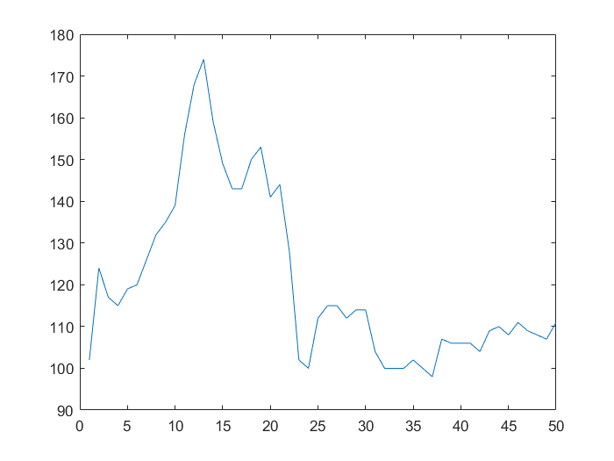

Plot of Trend Component after separating it from Noise and Oscillatory components:

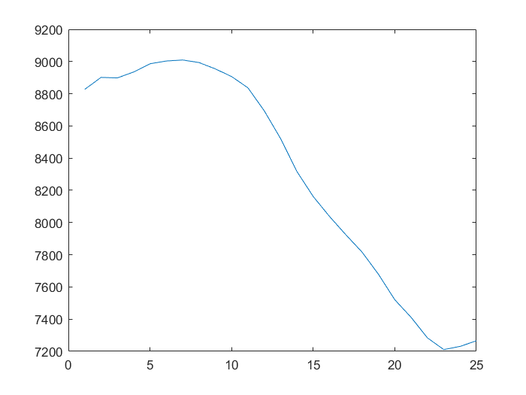

Plot of Oscillatory Component:

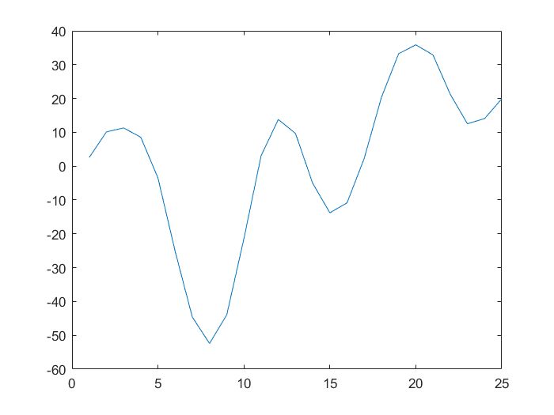

Plot of Noise Component:

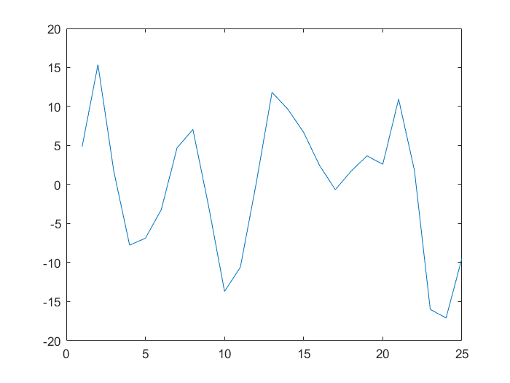

Dataset2: Total annual rainfall (in inches), London, England, 1813 to 1912

Actual plot of timeseries:

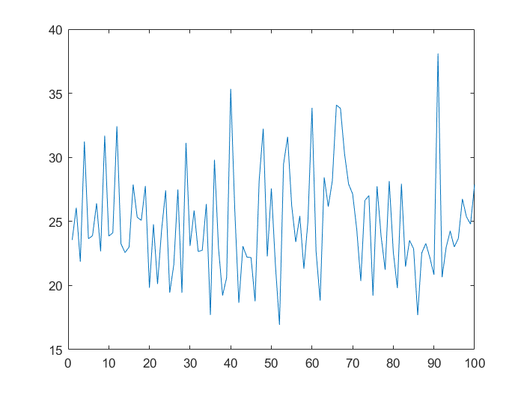

Plot of Trend Component after separating it from Noise and Oscillatory components:

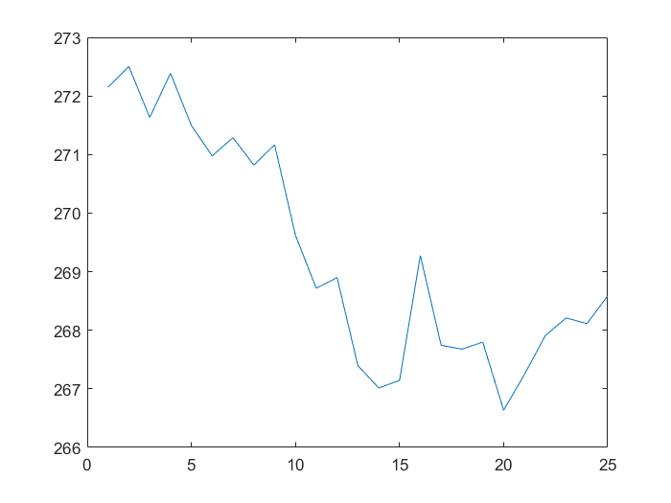

Plot of Oscillatory component:

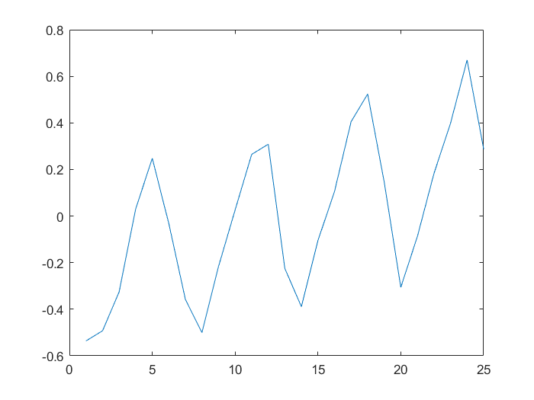

Plot of Noise Component: 